# Frontend Web assignment (Individual study point exercises - 14 study points)

**Hand-in**: By Moodle.

**Solution**: Hand-in a zip file with documentation of

a) source code and JUnit tests (NetBeans project as zip file);

b) database (SQL scripts for database creation, insert of test data, possibly views and/or stored procedures).

Name the zip file “*<user name>-<firstname_lastname>.zip*”

**Deadline**: Sunday February 26th at 23.59

## Introduction

In this assignment, you will be working individually on both functional and non-functional requirements for a small fictive library system.

## Requirements to the development process

Quality must be built into the application, one story at time. Continued assurance of quality is achieved by continuous and automated execution of the aggregated testing. Test of the functionality (the user stories) can be done manually via the user interface, but data mappers must be tested via JUnit. It is important not to start implementing a new story before confidence in the existing user stories is assured.

## Functional requirements

All students must implement user story 1 -2.

Yellow students must also implement user story 3.

Red students must also implement user story 4.

User story 5 is optional.



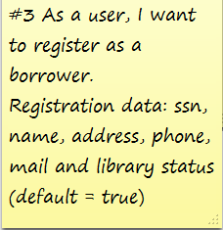



## Non-functional requirements

All students must implement story 6 -7.

Yellow students must also implement user story 8.

Red students must also implement user story 9.

